Day 30

DIY

Q1. How to use an Amazon S3 trigger to invoke a Lambda function?

Problem Statement:

Use the console to create a Lambda function and configure a trigger for Amazon Simple Storage Service (Amazon S3). The trigger invokes your function every time that you add an object to your Amazon S3 bucket.

Solution:

1. Go to Iam role  and create role

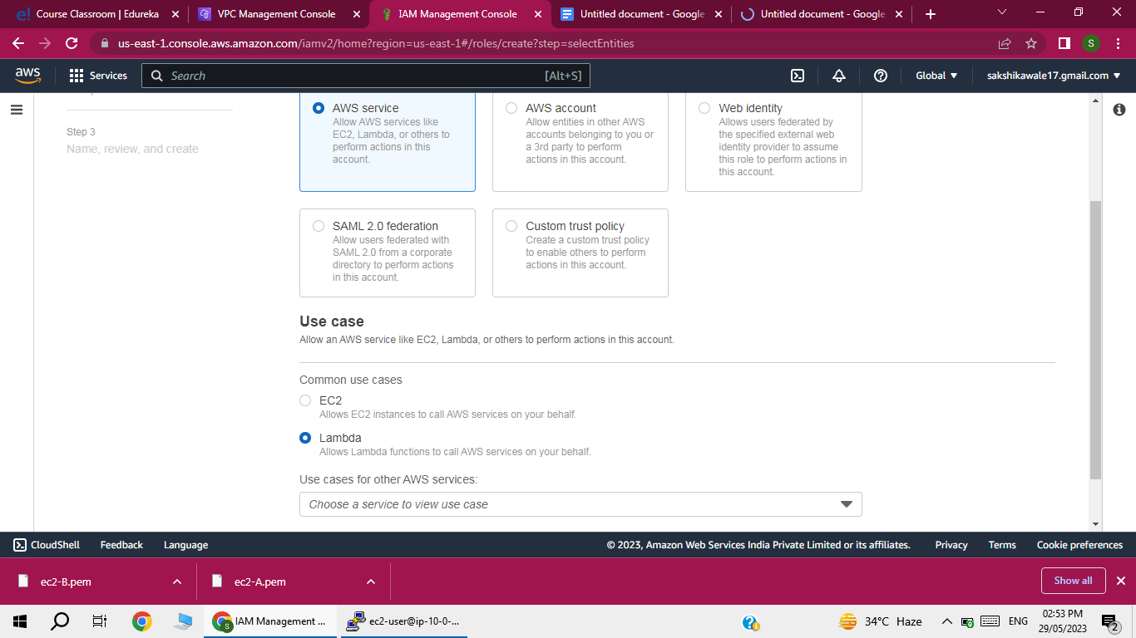

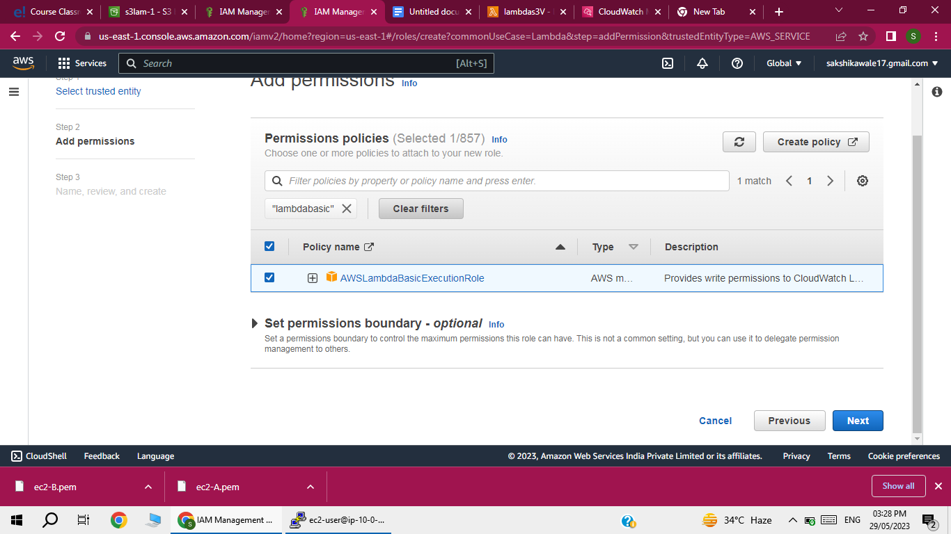

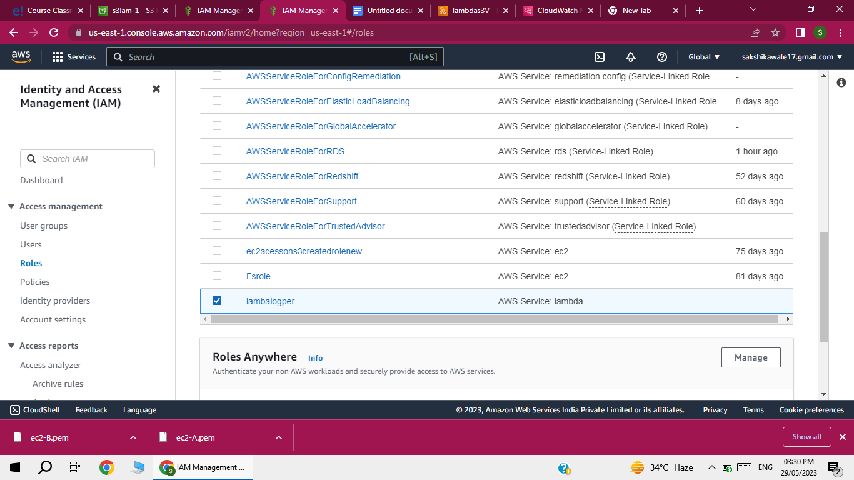

2) create lambda function

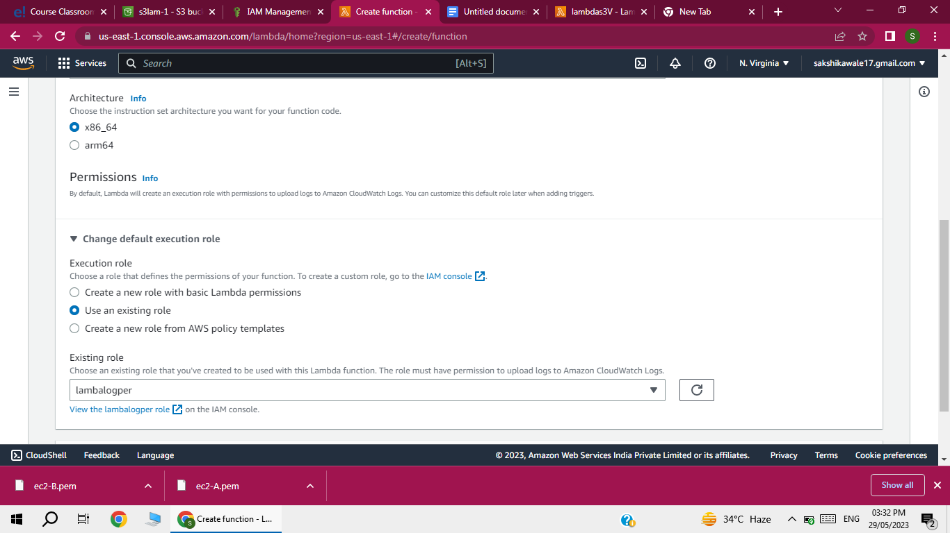

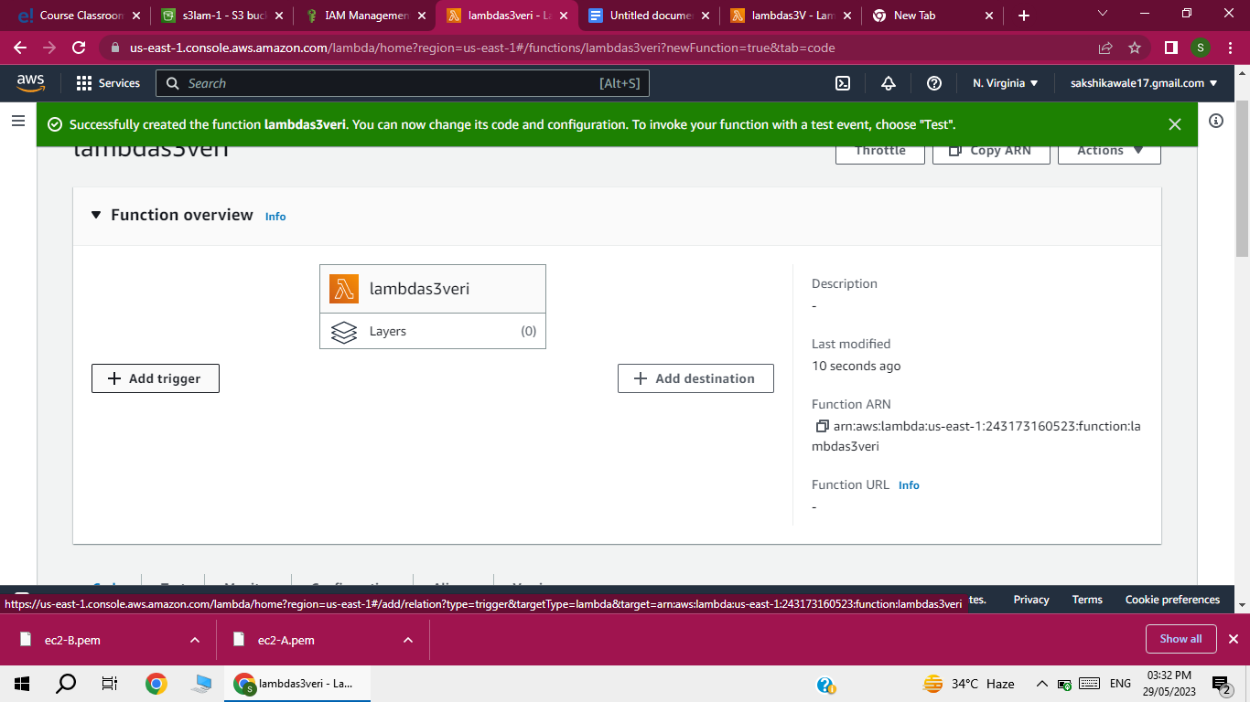

3) Go to S3

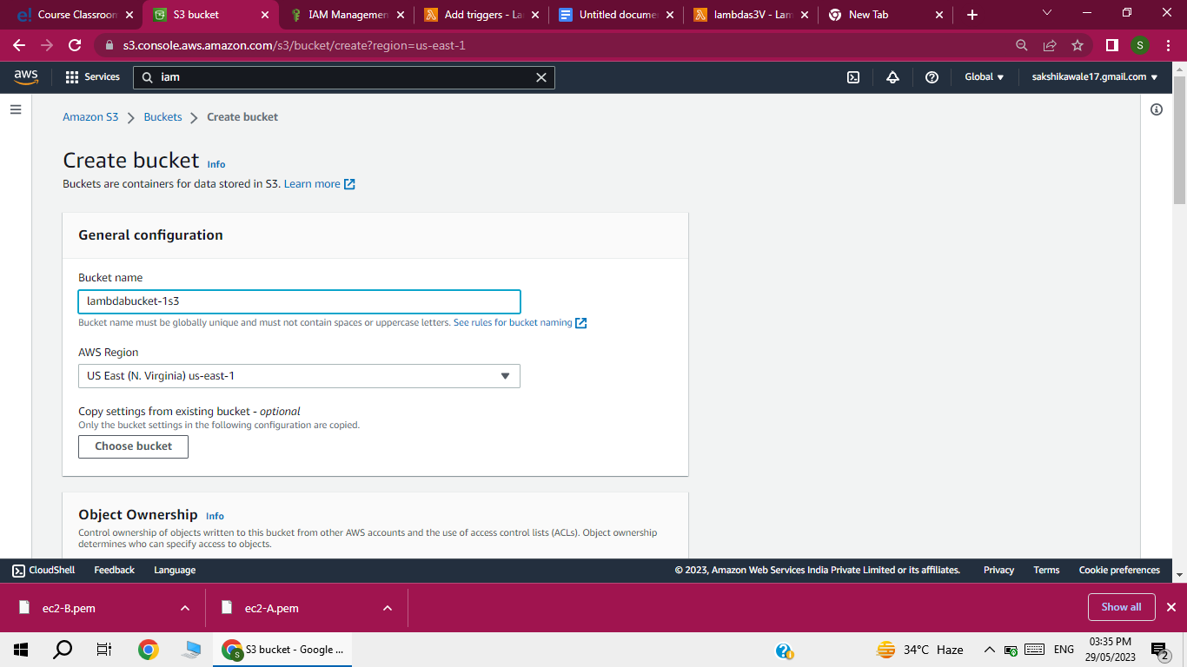

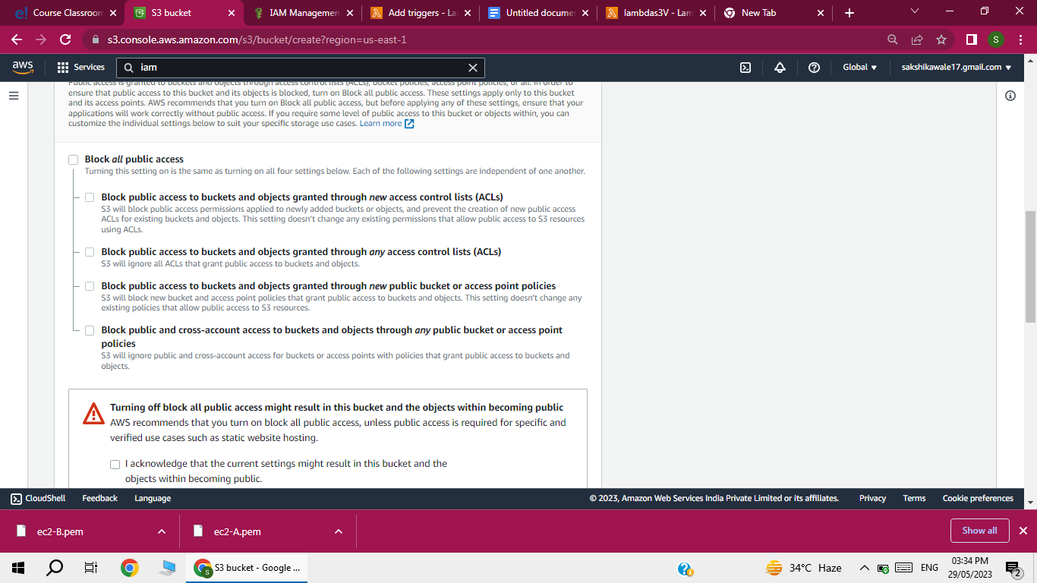

After creating lambda function  go to code section add   print(event) save and deploy

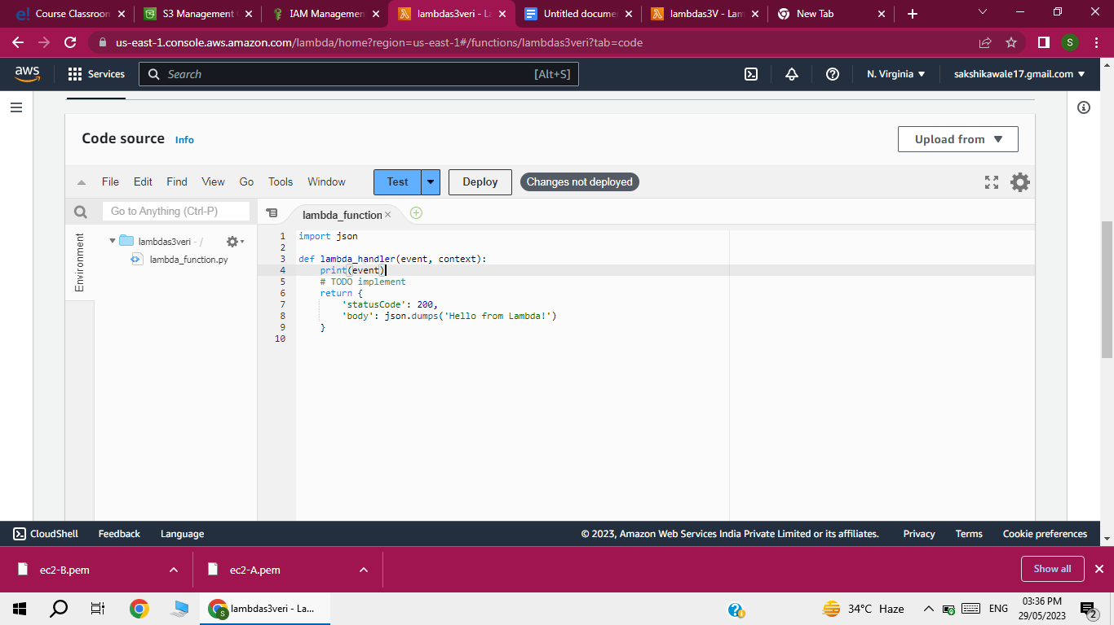

Now go to trigger  and select the bucket

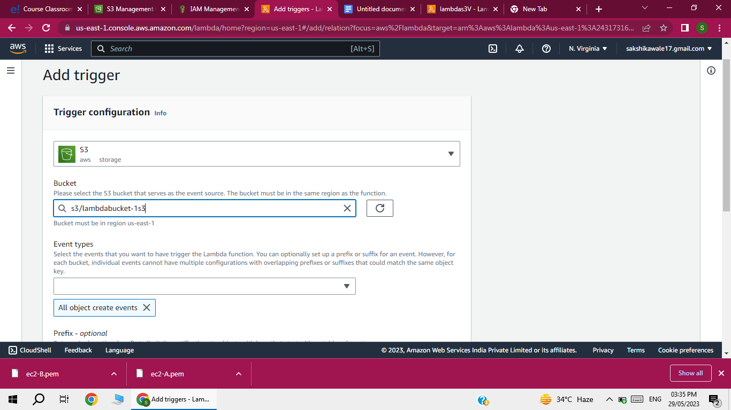

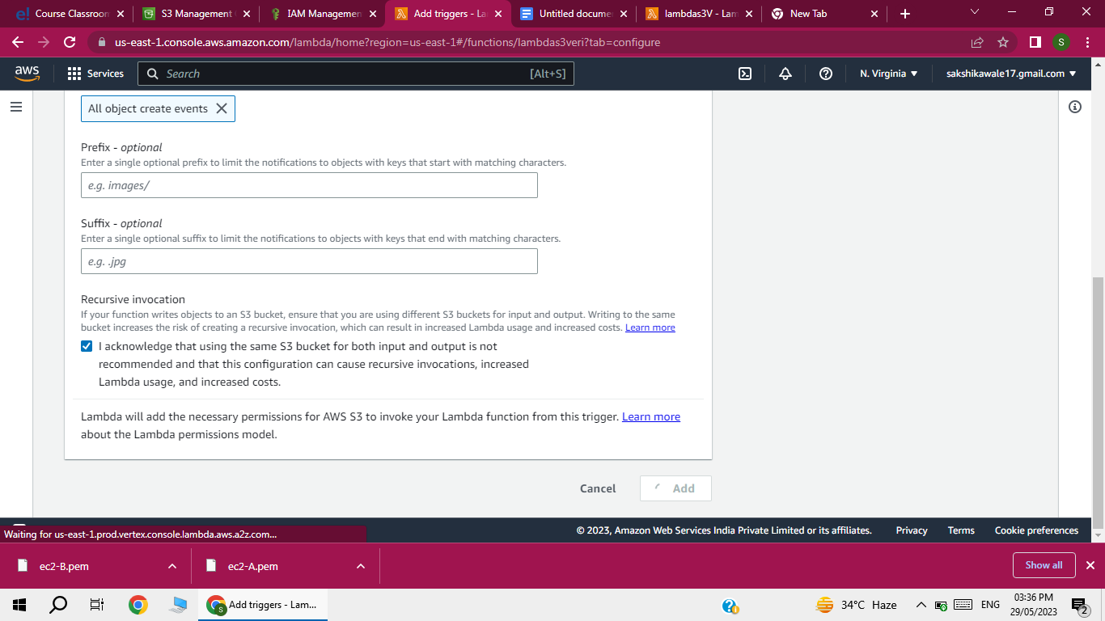

Add the   (upload ) file in s3 bucket which created before

In lambda function click on monitor tab under

Click on  view cloudwatch logs

